Workshop Bodenburg
The Ensemble
Headed by:
Erwin Döring
Participants:
Anselm Homey
Nadja Kugler
Ute Krieger
Ina Seitz
Julia Marbach
Nadine Wengerek
Kerstin Möller
Ulla Grimm
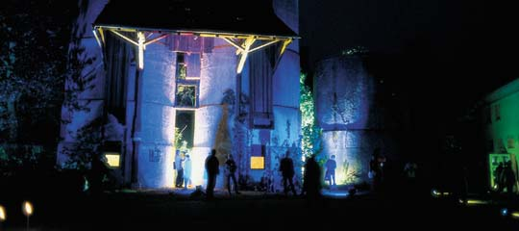
The group had the task of lighting the overall ensemble in the central courtyard, which included the large barn with stables, a silo comprising three towers, a bell tower and the former bulls' stable.
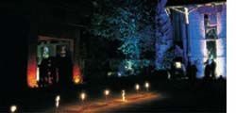
Given the ensemble of buildings and structures, the group decided to light it as if it were an open-air stage, whereby the silos were regarded as 'scenery' and the open space between the buildings was to become the piazza, a place for entertainment and for people to meet. The significance and 'theme' of each of the structures was then defined: the silos became the backdrop; it was decided to give the former bulls' stable with its striking roof structure special attention in contrast to the partly broken down barn on the opposite side of the central open space. The illumina-tion of the buildings was to under-line the architecture of the struc-tures and bring out the above-mentioned themes. The concept for the silos received special attention, because the lighting in this section of the ensemble served the purpose of changing light, colour and space to create a new plane of reality.
The two main silo towers were illuminated in a soft blue, changing to light mauve. Asymmetrical projectors (4200 K) were positioned to illuminate the sides of the silos. The front surfaces and the interior of the silos received white lighting by symmetrical projectors. The group decided to light the wooden framework structure of the silo and the canopy using 250 W NAV-TS lamps. The background lighting to the silos was 4800 K to produce harmonious contrasts. In the niche between the silos there was a lilac tree in full pink blossom. This was incorporated into the concept (150 W CDM-T plus red filters).
The former bulls' stable together with the old barn form the framework of the ensemble. The illumination of these two areas was therefore reduced in effect to allow the silos to be the dominant feature in the setting. The bulls' stable was illuminated in a discreet green tone (HAL 300 W QT DE 12, equipped with pastel coloured filters). The exterior of the old barn and the walls bordering the site were reticently lit using 60 W QT DE-12 halogen spots. The stones on the piazza were to remain dark. To create the impression of an auditorium a row of flaming torches were set up parallel to the buildings to lead visitors into the area.
The visitors reacted warmly to the ensemble setting. The colours were carefully chosen in accor-dance with the theory of colour. The result: a vision of colours and light in an architectural (stage) setting.

